5TH ANNUAL ADDICTION SYMPOSIUM
Center for Addiction
Research & Education
Focusing on Marijuana Research
April 10, 2017
Beginning at 9:15am,
McKnight Brain Institute, DeWeese Auditorium:

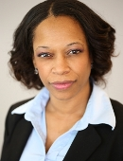
Keynote Speakers:

Yasmin Hurd, Ph.D.
Professor of Psychiatry, Neuroscience, and Pharmacological Sciences
Icahn School of Medicine at Mount Sinai
Alan Budney, Ph.D.
Professor of Psychiatry
Geisel School of Medicine, Dartmouth College

AFTERNOON POSTER SESSION
2:30-4:30pm in the Health Professions/Nursing/Pharmacy Building Atrium

